AWS Route tables

1.Go to vpc and pick Route Tables

2.Create a route table

3.Provide a name and attach vpc

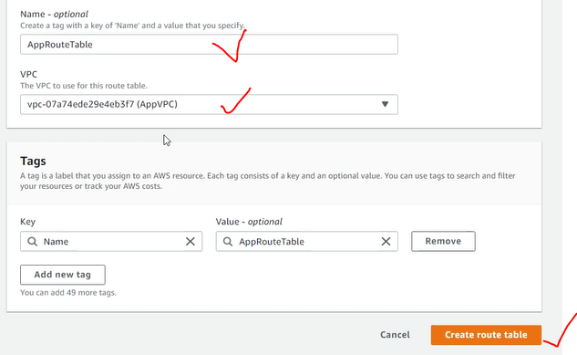

4.Edit routes and add a route for internet gateway

5.Attach subnets

